**Career Services**

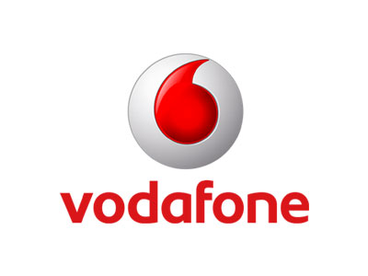



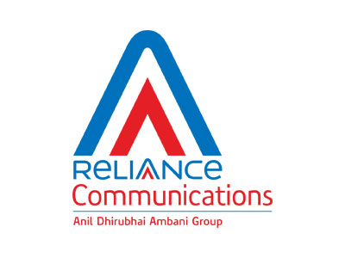



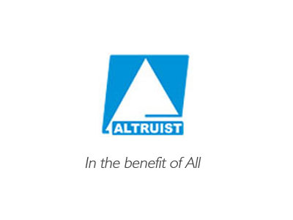

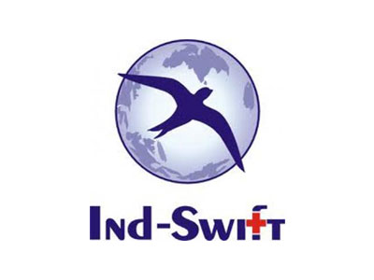



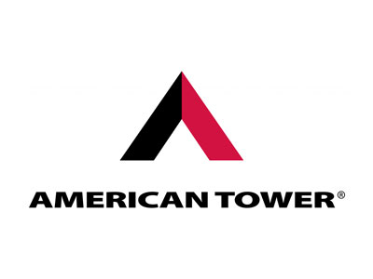

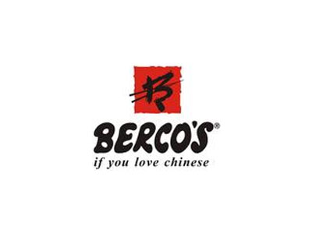



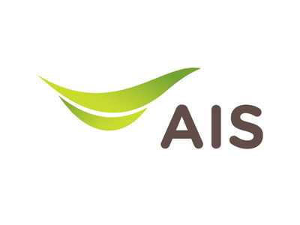





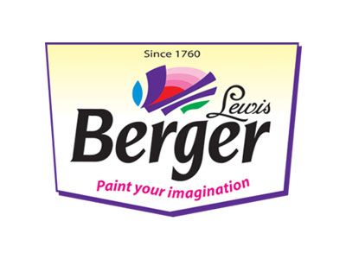



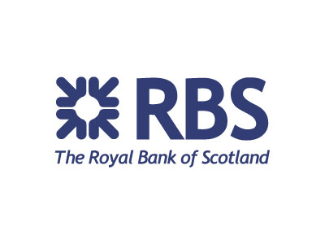

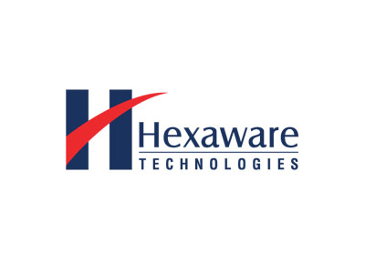

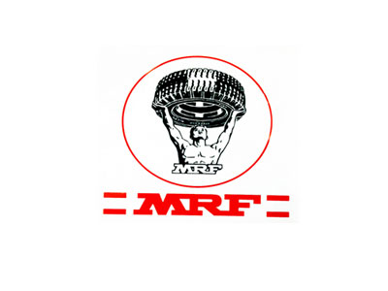



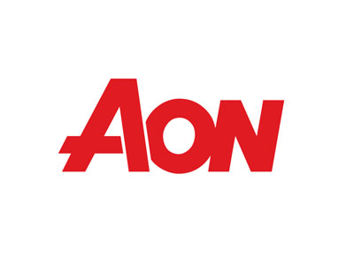











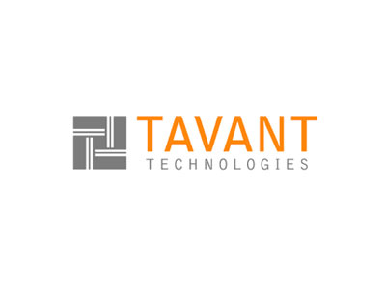







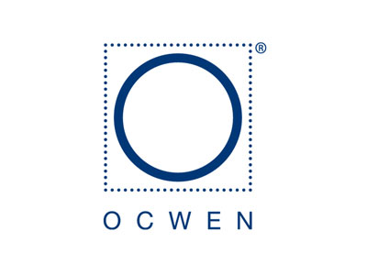

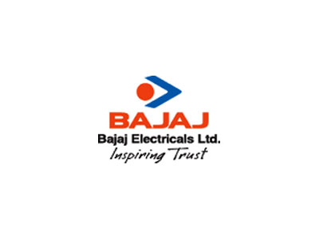







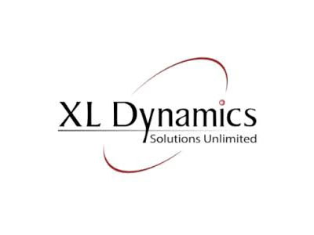

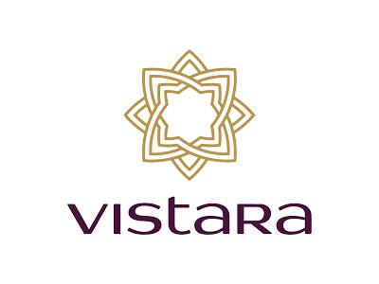

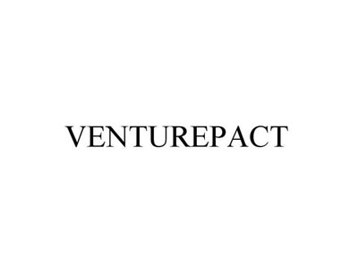

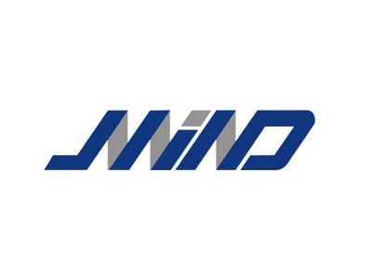



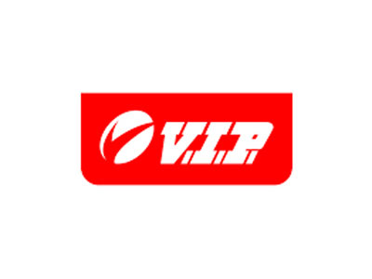

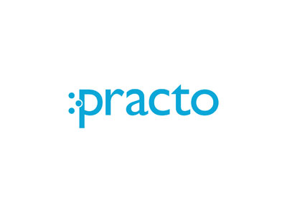



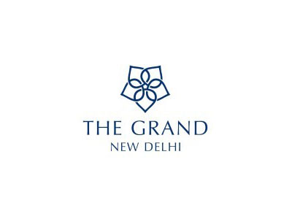



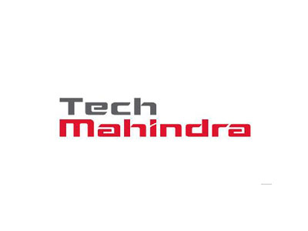

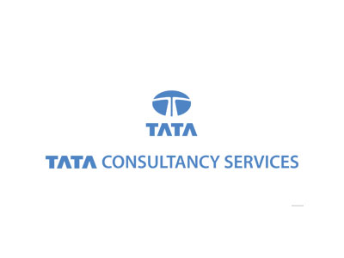

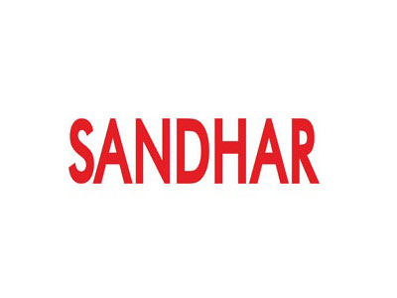



**OUR PLACEMENT HIGHLIGHTS**

Read on to learn more about our impeccable placement record!

[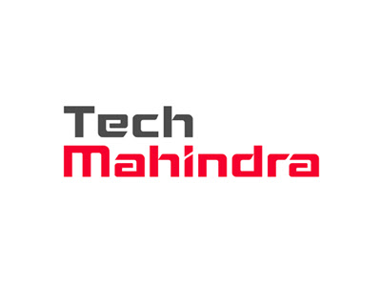](http://www.lpu.in/student_services/images/placement/full/techMahindra.jpg)

**250 OFFERS MADE ON DAY 1 BY TECH MAHINDRA**

* *All B.Tech and MCA*

This is the highest number of offers made by Tech Mahindra at any campus!

**610 STUDENTS SELECTED BY COGNIZANT IN 1 DAY!**

* *All B.Tech, M.Tech and MCA*

LPU set a new record on Day 1 by placing 610 students in 2015 and 550 students in 2016. This is a record for any university in North India!

[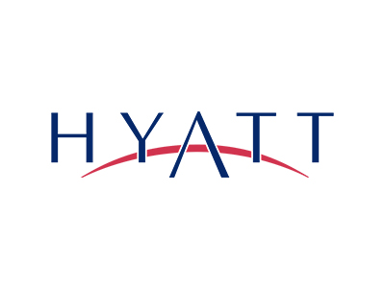](http://www.lpu.in/student_services/images/placement/full/ip1.jpg)

**HYATT SELECTS STUDENTS @ 15 LAKHS PACKAGE**

* *Hotel Management*

Hyatt, the global hospitality super brand selected 6 LPU students at record packages!

**PRACTO SELECTED LPU STUDENTS @ 6.5 LAKHS PACKAGE**

* *MBA, B.Tech CSE/IT*

Practo, one of India's leading start up brands, selected 28 LPU students at 6.5 Lakhs Packages.

[](http://www.lpu.in/student_services/images/placement/full/ritz-qatar.jpg)

**RITZ CARLTON OFFERS DREAM PACKAGES**

* *Hotel Management*

Ritz Carlton & Qatar Airways offered dream package of over 20.5 lakhs per annum

[](http://www.lpu.in/student_services/images/placement/full/ip1.jpg)[](http://www.lpu.in/student_services/images/placement/full/ip7.jpg)[](http://www.lpu.in/student_services/images/placement/full/ip2.jpg)[](http://www.lpu.in/student_services/images/placement/full/ip4.jpg)[](http://www.lpu.in/student_services/images/placement/full/ip5.jpg)[](http://www.lpu.in/student_services/images/placement/full/ip6.jpg)[](http://www.lpu.in/student_services/images/placement/full/ip3.jpg)[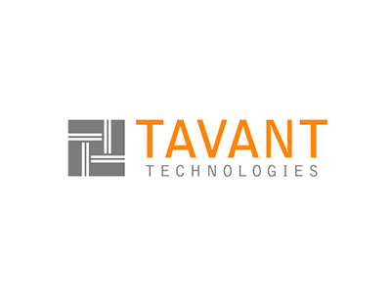](http://www.lpu.in/student_services/images/placement/full/ip8.jpg)[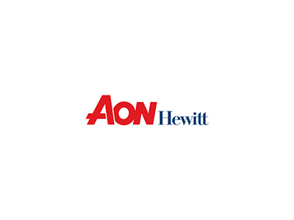](http://www.lpu.in/student_services/images/placement/full/ip9.jpg)

**INTERNATIONAL PLACEMENTS @ LPU**

* *Hotel Management, MBA, B.Tech Civil, B.Tech Mechanical, B.Tech ECE/EEE, Architecture*

International Companies like Hyatt (USA), Ritz Carlton (USA), Adani Wilmar (Africa), Altruist (Africa), Al-Rakha (Dubai), Dharam Consultancy (USA) selected LPU students for International locations

**DREAM PACKAGES OFFERED TO LPU STUDENTS**

* *All B.Tech, M.Tech and MBA*

Top corporate like Verizon, Gemalto, Josh Technology, Asian Paints, Berger, LG Soft, Tavant, Gemalto, selected LPU student for dream package i.e. 4.5 Lac above

[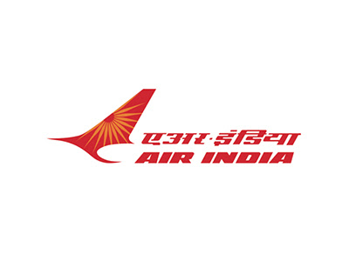](http://www.lpu.in/student_services/images/placement/full/air-india.jpg)

**AIR INDIA HIRED VERTOS AT OVER 8.5 LAKH ANNUAL PACKAGE**

* *Hotel Management*

Air India, India's oldest aviation brand, selected LPU's hotel management students at a CTC of 8.5 Lakhs.

**100% PLACEMENT OF ELIGIBLE STUDENTS IN HOTEL MANAGEMENT**

* *Hotel Management*

HM students of LPU got placed with some of the reputed National and International brands like Hyatt, Oberoi's, Leela, Marriott, Grand Hayatt, Zuri and many more...

**100% PLACEMENTS OF ELIGIBLE STUDENTS IN MBA**

* *Management - MBA*

MBA students got placed with world's best corporates. Some of the leading recruiters are Practo, Think and Learn, Colgate Pamolive, Bajaj Electrical, Redington, MRF, Bridgestone, Wipro CCLG, Canara Bank, Madura F&L, Axis Bank, ICICI Securities, RBS, WNS, Ocwen Financial Services etc

**RECORD PLACEMENTS IN ENGINEERING STREAMS**

* *All B.Tech*

LPU sets a new record in north india by placing maximum number of eligible students in Engineering i.e. 86% in 2014-2015 passout batch and over 80% in 2015-2016 batch, so far. (Till March End)

**RECORD PLACEMENTS IN CSE/IT & ECE**

* *CSE/IT*

Top nationals and multiationals like Cognizant, Tech Mahindra, iGate, ITC Infotech, Amdocs, Atos, Mphasis, Unisys, AON Hewitt, MAQ, CSS Corp, HCL and many more, have shown trust in LPU and recruited our students for PAN India operations

[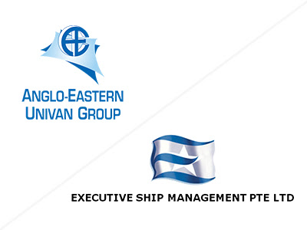](http://www.lpu.in/student_services/images/placement/full/anglo-exe.jpg)

**TOP 2 SHIP MANAGEMENT COMPANIES RECRUITED LPU STUDENTS**

* *B.Tech Mechanical*

Anglo-Eastern (India's number 1) and Executive Ship Management Company (2nd biggest ship management company) recruited 65+ Mechanical and Electrical students from LPU

**INDUSTRY COLLABORATIONS**

SEE WHY OUR STUDENTS ARE INDUSTRY'S TOP CHOICE.[**READ MORE**](http://www.lpu.in/academics/industry-immersion.php)

**LPU HOSTS HUNDREDS OF RECRUITERS**

See our record..

[](http://www.lpu.in/student_services/images/placement/full/redington.jpg)

**REDINGTON**

* *MBA - 24*

[](http://www.lpu.in/student_services/images/placement/full/igate.jpg)

**IGATE**

* *B.Tech CSE/IT, ECE, EEE - 73*

[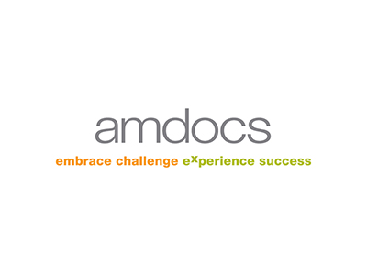](http://www.lpu.in/student_services/images/placement/full/amdocs.jpg)

**AMDOCS**

* *B.Tech CSE/IT, ECE, MCA - 47*

[](http://www.lpu.in/student_services/images/placement/full/itc-infotech.jpg)

**ITC INFOTECH**

* *B.Tech CSE/IT, ECE, MCA - 28*

[](http://www.lpu.in/student_services/images/placement/full/ip9.jpg)

**AON HEWITT**

* *B.Tech CSE/IT, ECE, MCA - 36*

[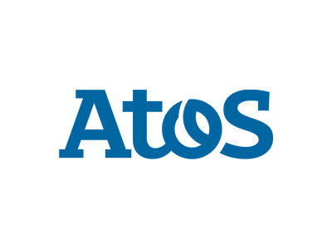](http://www.lpu.in/student_services/images/placement/full/atos.jpg)

**ATOS**

* *B.Tech CSE/IT - 31*

[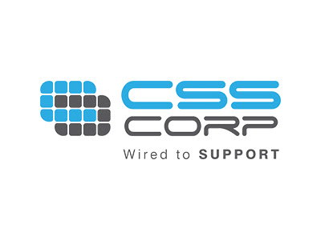](http://www.lpu.in/student_services/images/placement/full/css-corp.jpg)

**CSS CORP**

* *B.Tech CSE/IT, ECE and M.Tech CSE/IT, ECE, MCA - 30*

[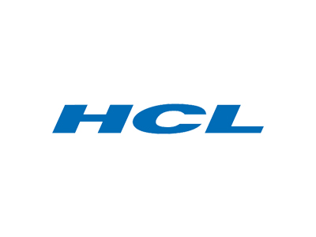](http://www.lpu.in/student_services/images/placement/full/hcl.jpg)

**HCL**

* *B.Tech CSE/IT, ECE - 40*

[](http://www.lpu.in/student_services/images/placement/full/simplex.jpg)

**SIMPLEX**

* *B.Tech Civil - 35*

[](http://www.lpu.in/student_services/images/placement/full/mphasis.jpg)

**MPHASIS**

* *B.Tech CSE/IT, ECE - 34*

[](http://www.lpu.in/student_services/images/placement/full/unisys.jpg)

**UNISYS**

* *B.Tech CSE/IT, ECE, Civil and Mechanical - 32*

[](http://www.lpu.in/student_services/images/placement/full/janalakshmi.jpg)

**JANALAKSHMI FINANCIAL SERVICES**

* *MBA - 27*

[](http://www.lpu.in/student_services/images/placement/full/think-learn.jpg)

**THINK N LEARN**

* *MBA and B.Tech All Streams - 33*

[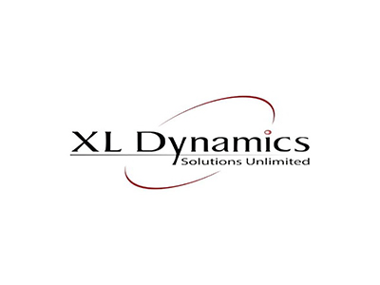](http://www.lpu.in/student_services/images/placement/full/xl-dynamics.jpg)

**XL DYNAMICS**

* *MBA and B.Tech All Streams - 22*

[](http://www.lpu.in/student_services/images/placement/full/sandhar.jpg)

**SANDHAR TECHNOLOGIES**

* *B.Tech Mechanical, MBA, B.Tech EEE - 23*

[](http://www.lpu.in/student_services/images/placement/full/adi-birla.jpg)

**MADURA FASHIONS AND LIFESTYLE**

* *MBA - 23*

[](http://www.lpu.in/student_services/images/placement/full/rbs.jpg)

**RBS**

* *Graduates BBA, B.Com and M.Com - 26*

[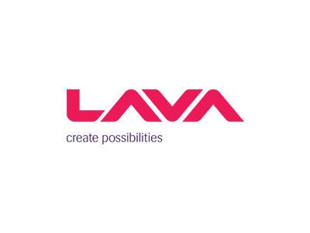](http://www.lpu.in/student_services/images/placement/full/lava.jpg)

**LAVA INTERNATIONAL**

* *B.Tech ECE, EEE, Mechanical, Diploma and MBA - 22*

[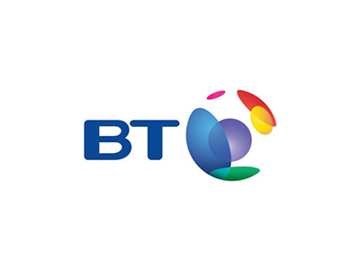](http://www.lpu.in/student_services/images/placement/full/bt.jpg)

**BRITISH TELECOM**

* *Graduates BBA, BCA, B.Sc., B.Com - 20*

[](http://www.lpu.in/student_services/images/placement/full/jubilant.jpg)

**JUBILANT FOODWORKS LIMITED (DOMINOS PIZZA INDIA LTD.)**

* *Hotel Management and MBA (ATH) - 36*

[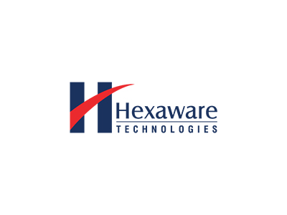](http://www.lpu.in/student_services/images/placement/full/hexaware.jpg)

**HEXAWARE**

* *B.Tech CSE/IT, ECE, EEE and MCA) - 16*

**THE CRORE CLUB**

Hear what our star performers have to say..



**Utkarsh Gautam**

Wireless Systems Engineer



**Neha Mahajan**

System Programmer



**Navtej Singh Sandhu**

Sr. Software Engineer



**Sarabmeet Singh**

Sr. Technical Head



**Parwinder Singh**

Business Intelligence Engineer

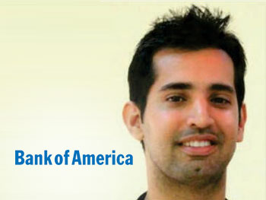

**Nikhil Vasudev**

Technology Lead



**Raminder Kaur**

System Validation Engineer



**Vikas Yadav**

Senior Software Engineer



**Dishant Sikka**

Senior Analyst

**WHAT RECRUITERS THINK?**

Tens of recruiters visit LPU every week! See what they have to say...

* 

*LPU students' performance was the best in North India*

**MR. GANTAVYA MALHOTRA, EXECUTIVE HR**NEC Technologies India

* 

*I found LPU has the best practices. I will take this experience and provide the feedback to other campuses*

**MR. M. BALAMURUGAN, HEAD- CAMPUS RECRUITMENT**VERIZON

* 

*I was amazed by the students programming skills and many were able to do complex programs at ease*

**MR. KARISHNA BALAGURUNATHAN**HEXAWARE

* 

*Most humble and courteous set of candidates developed with fantastic entrepreneurial skills inculcated to the base.*

**MS. URVI KHAN, SITE HEAD - RESOURCING INDIA**RBS

* 

*Energy and knowledge level of students are fantastic. LPU is imparting quality education to the students.*

**MR. D.P. DASS, DGM- HR**L n T Construction

* 

*Experienced inimitable amalgamation of global culture. One of the best IT enabled campuses in India. Warm hospitality.*

**MS. VIJAYA KARMAKAR**Indigo Airlines

**PLACEMENT STATISTICS**

Unbeatable Placement Record in North India

**No. of Companies Conducting drives**

**Avg. Starting Package**

**Max. & Min. Package**

**CAREER SERVICES**

Enhancing employability through extra academic rigors

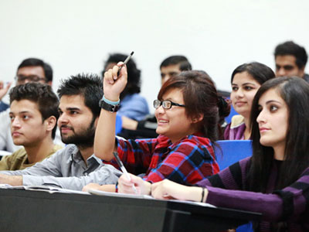

**PROFESSIONAL ENHANCEMENT PROGRAM**

LPU strongly believes in complementing its academic endeavours by providing highly comprehensive pre-placement grooming to its students.

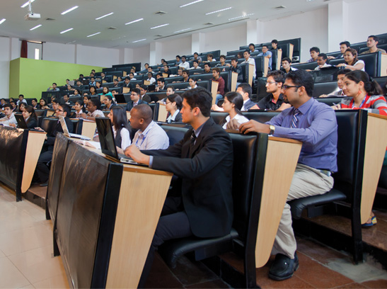

**TECHNICAL CLASSES & WORKSHOPS**

At LPU, workshops like iOS and android development are a regular feature for exchange of information and creating awareness among our students and faculty about the emerging tech and business trends.

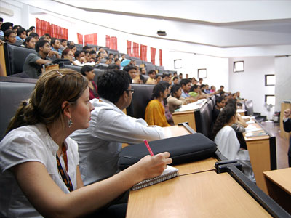

**MOCK DRIVES**

The Careers department regularly conducts mock drives, interviews and group discussion to train the students in a real life environment.

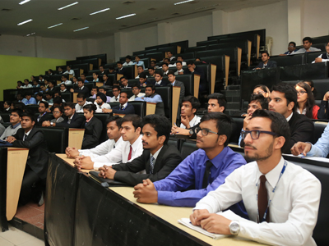

**SCHOOL PLACEMENT COMMITTEES**

At LPU, each of the 28 schools have a placement committee that looks after the curriculum to ensure that it is keeping up with latest industry trends.

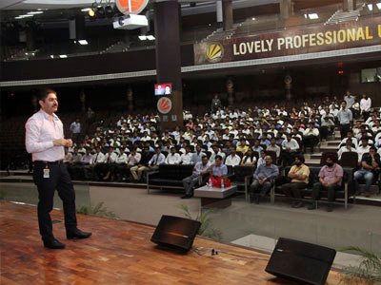

**GUEST LECTURES**

LPU believes that the academic purpose of education can only be fully achieved by taking the students out from the bounds of classrooms and labs. That's why we host guest lectures from industry professionals regularly!